Title (16pt Times New Roman)

Author names^{1*} (12pt Times New Roman)
¹Affliation
*Corresponding author, e-mail address

Body text is two lines below author details and should summarise the key findings of the work, results and methods used. Abstracts should be limited to 1 page and include one figure, longer abstracts will not appear in the program. These will be loaded directly into an abstract book distributed at the conference. The font size should be 12pt and style should be Times New Roman.

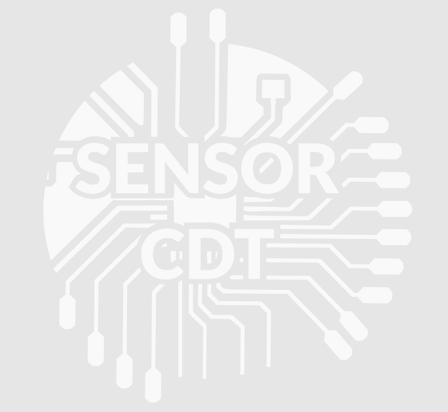
Figure 1. Figure captions are indented 5 spaces and justified. Font size is size 11 and style is Times New Roman. The figure should be above the caption and large enough to read.

References
- References should be font size 11 and times new roman

